Chapter2
The Mystery of the Construction Details
The Devil (or Genie?) is in the Details

Here are some photos of the excessive detail machined into this presentation model.

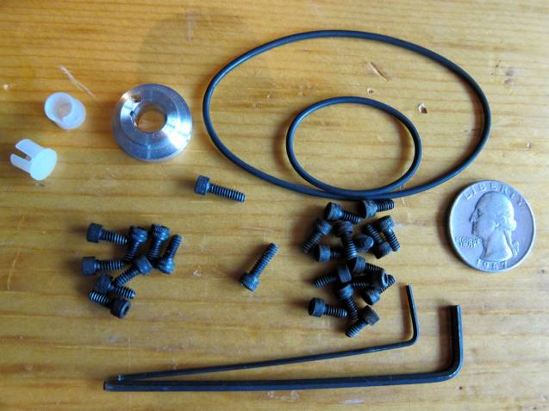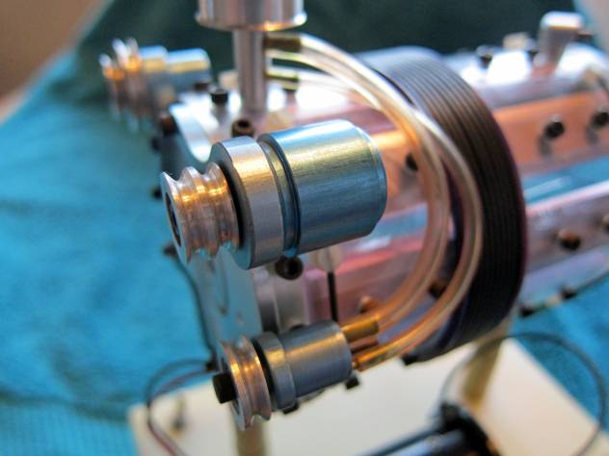

Mini Fasteners and Parts removed for disassembly. Machining detail in the double sheave alternator pulley
Apparently Supper Glue was not an option with ball bearings no less

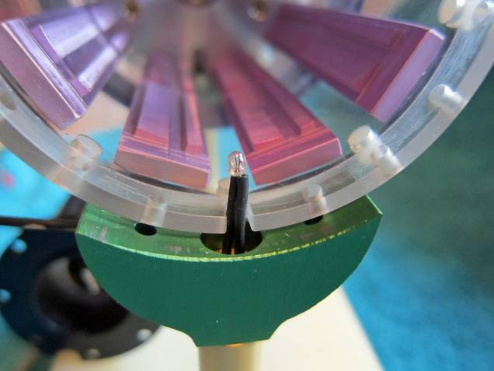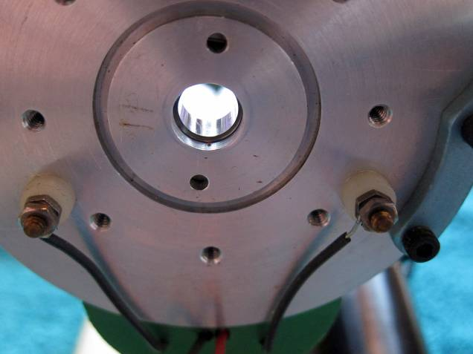

Note the back “Grain of Wheat Lamp”. Also note that These black wires are from the model “Floating Flux
the protrusions on the Stator Base Plates have been Field”. There is no electricity used here yet insulated
re-milled to a radius to match the Rotor Assembly. The terminals have been provided. These details don’t
back side of these same Plates have been milled to follow the actual EMA4 Engine since individual cables
match the ID of the poly-carbonate clear plastic case. were used for the FFF and not one long solenoid.

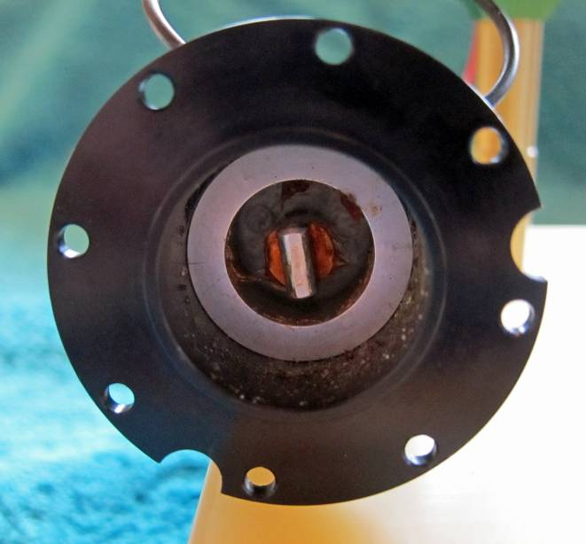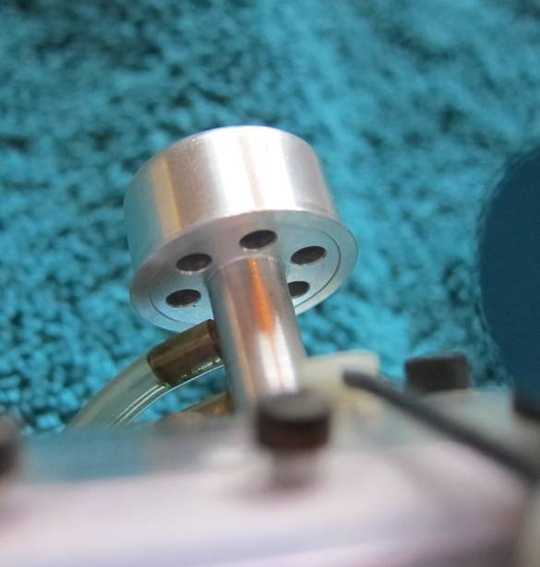

The milled front end commutator housing showing Precession holes machined in the two piece model
precession drilled and reamed fastener holes. The larger intake air filter. Unless the model is turned on it side
half moon cuts are to match the landing terminals these details can’t be seen, yet their cost were
for the wire of the model FFF. certainly reflected in the final invoice.

Verification of Construction Details between the EMA0 and the EMA4

A number of the constructions features observed on the EMA0 have already been seen in photos of the EMA4. However, having a second source of information helps verify what has been interpolated from a series of low resolution photographs.

Low Pressure Air Plumbing

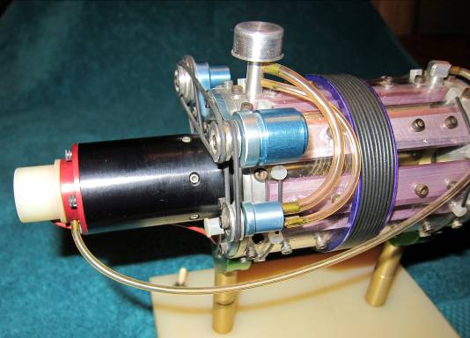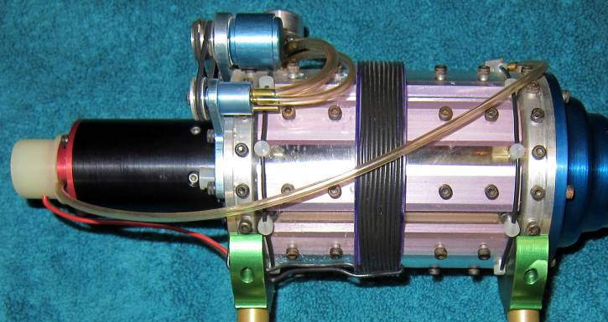

Oblique view showing Air Plumbing Side view showing Air Plumbing

The air flow piping is clearly laid out on the EMA0. In the Pulse Engine patent illustrations the air flow path is broken up among several views and thus leaves room for alternative interpretations. In the EMA0 it appears that outside air was pumped into the front of the engine and then recovered from the rear to be piped to the rotor commutator section. From hear it flows into the stator commutator section (front arc chamber) and was then exhausted out through the stator section (back arc chamber).

Conductor Count of the “Floating Flux Field” (FFF)

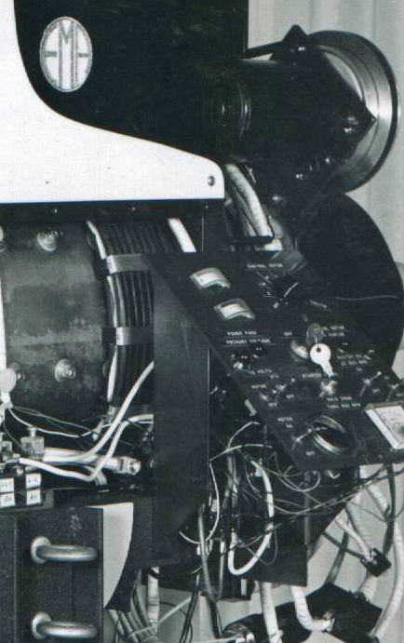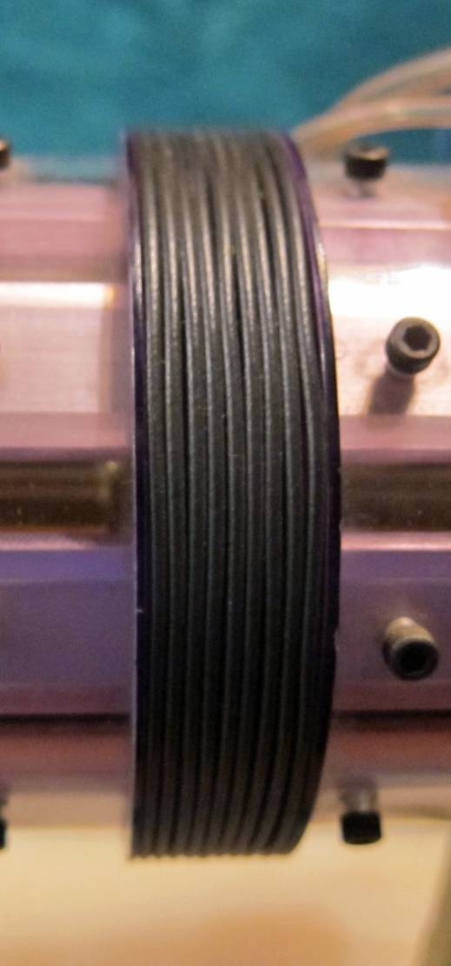

EMA4-E1 Showing partially obstructed FFF viewing The modeled FFF on the EMA0

There has been somewhat of an ongoing debate as to the number of conductors that composed the “Floating Flux Field” sub-assembly on the EMA4-E1. This is unresolved because of the limited resolution available in the surviving photos. Also it appears that the number of cables was doubled when the EMA4 was retro-fitted to become the EMA4-E2. The EMA0 model is a representation of the original version EMA4. There are two layers of large cables seen in the photo above. The count has varied between 9 and 10. The EMA0 shows 9 cables. This could be because that was size of the available magenta coil form. Never-the-less, 9 cables on the EMA0 is one more point of reference as to how many were on the actual engine. This number is important because it determines the number of unit power supplies in the original design and therefore has a huge impact on various proposed wiring topologies.

The GD documents claim that Paul Lewis had this model on display in his office for some time to help potential customers get an idea of what the Free-Energy Engine looked like for his Fascination Car. Perhaps it was Mr. Lewis who financed the construction of these models for his marketing purposes (and maybe keeping some of his underemployed machinists productive), keeping some for his sales efforts and sending one copy to Mr. Gray?

